* Data Structure is a **way of organizing data**. So that it can be **used effectively.**
* Data Structure is the **representation** of the **logical relationship exists between the individual element of data**.
* Data Structure is **logical or mathematical model of a particular organization**.
* Data Structure is the way of organizing data items that consider not only the element store but also their relationship between each other.

***Which Data Structure to use*?**

It always depends on the solution approach to solve the problem. It never depends on the problem nor on the data.

There is only one data type which is integer. Data type depends on the line of abstraction that distinguished between datatypes.

As Floats are collection of integers.

5 4 .6 9 here 5, 4, 6, 9 belong to class of integer.

# Classification

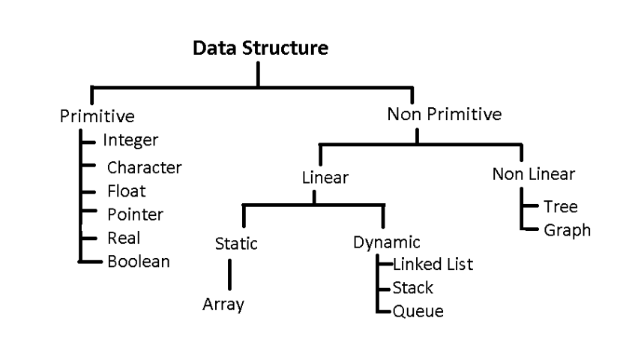

|  |  |  |
| --- | --- | --- |
| Data Structure | Linear | Non-Linear |
| Operations | Sequential | Random |

# Array

* Linear data structure
* Collection of similar data types
* Elements are stored in contiguous memory locations.
* Address of first element is known as base address and other elements are stored with a displacement of size of data type stored.
* Type – 1D, 2D, MD

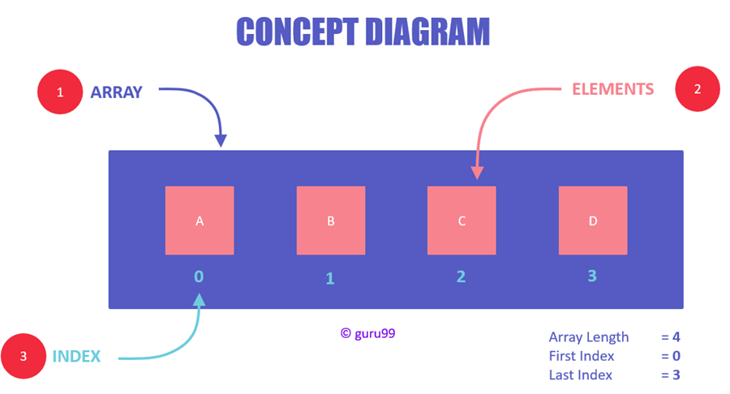

1D array

Note- Array doesn’t store the element value but it stores the address of element.

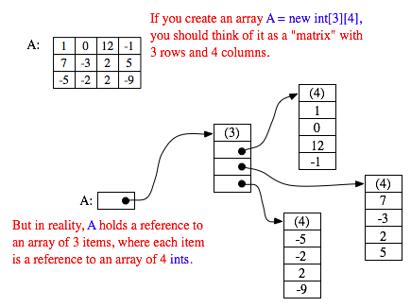

2D array

# Stack

* Linear data structure
* One open end and another closed end
* All operation is performed from opened end
* Uses **LIFO** (last in first out)
* The topmost element is pointed with a pointer called **TOP**
* Insertion operation is known as **push** and deletion as **pop**

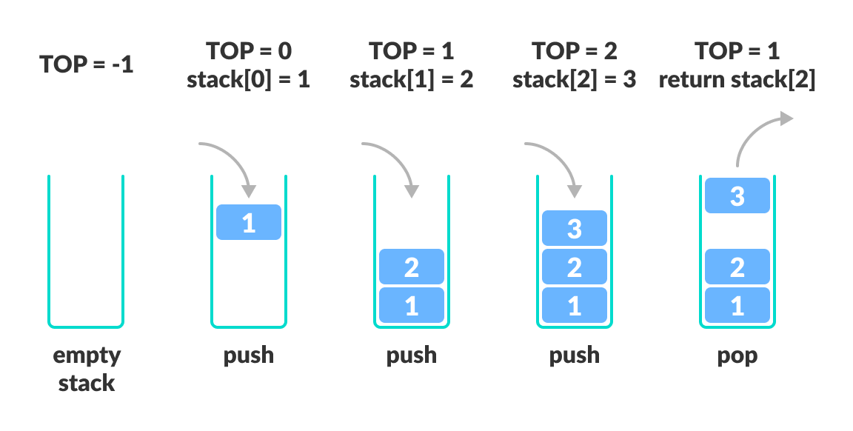

# Queue

* Linear data structure
* Both ends are open
* Uses **FIFO** (first in first out)
* It used two pointer **FRONT** and **REAR**
* Insertion (enqueue operation) are performed from rear and deletion (dequeue operation) are perform by front end

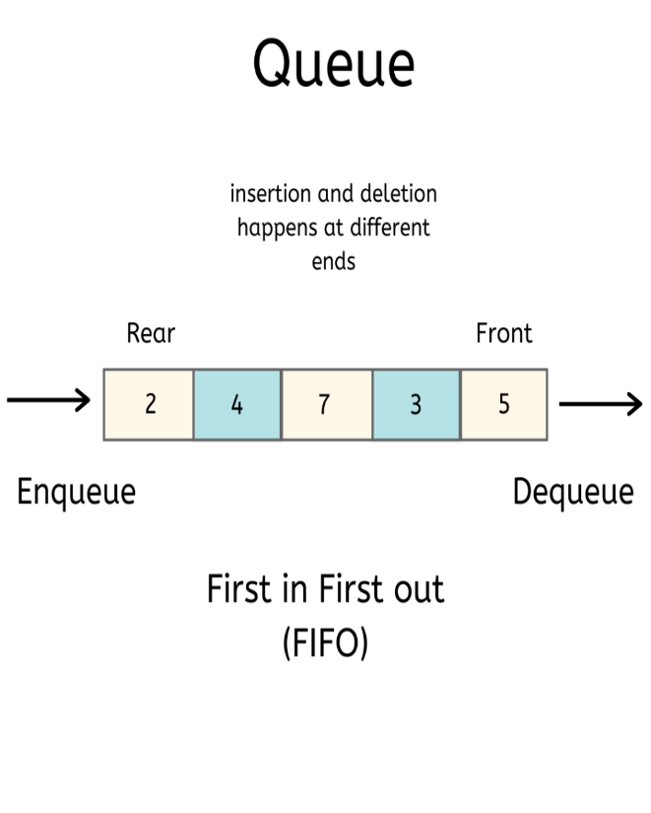

# Linked List

* Linear data structure.
* Element are stored inside nodes.
* Node contains at least two fields (1) Information/ Data (2) Address of next element.

***Types***

